**Searching for a Specific User and Updating the User Information..**

**Index page**

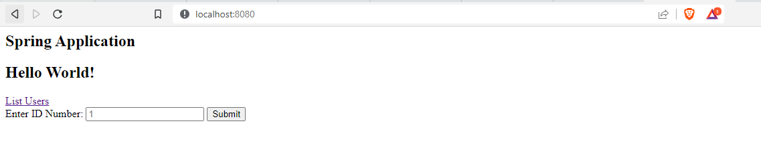

**List User**

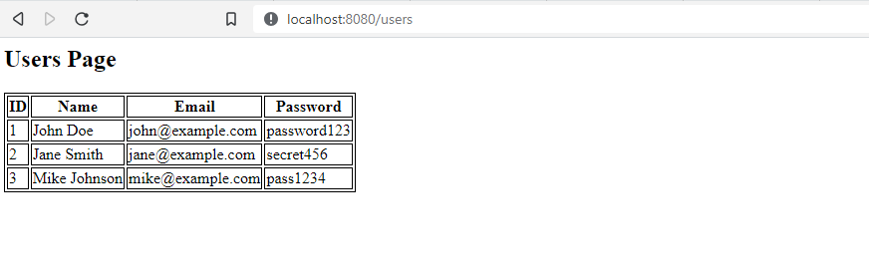

**Search User**

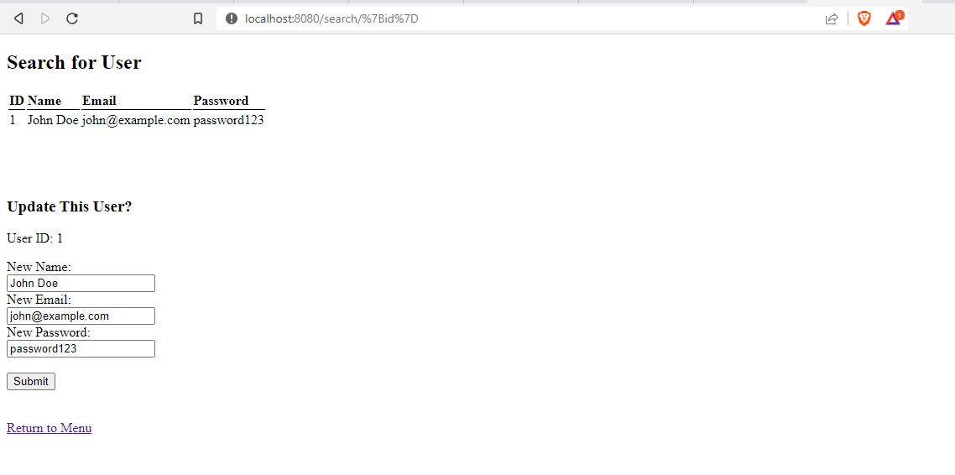

**Update Page**

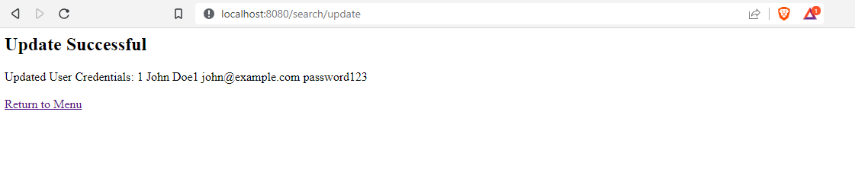

**Project Structure**

